1. Come up with 3 interesting business questions including one or two-term definitions (different from the class) to Q&A in FactResellerSales and its related tables in the **DB661** database.

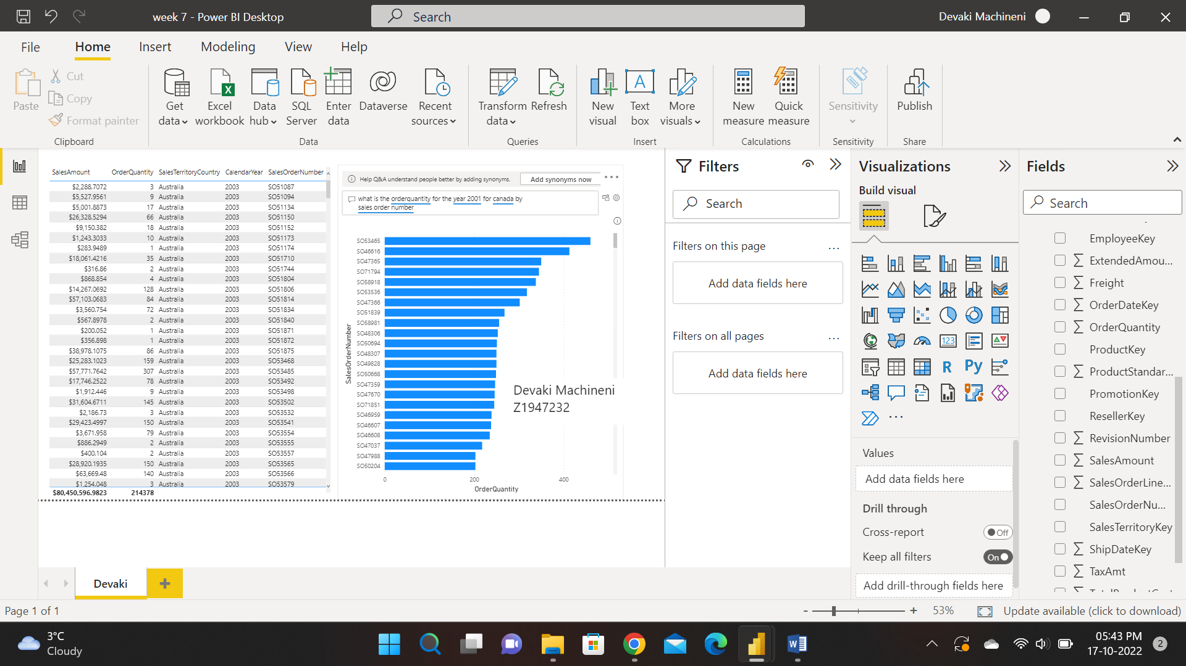

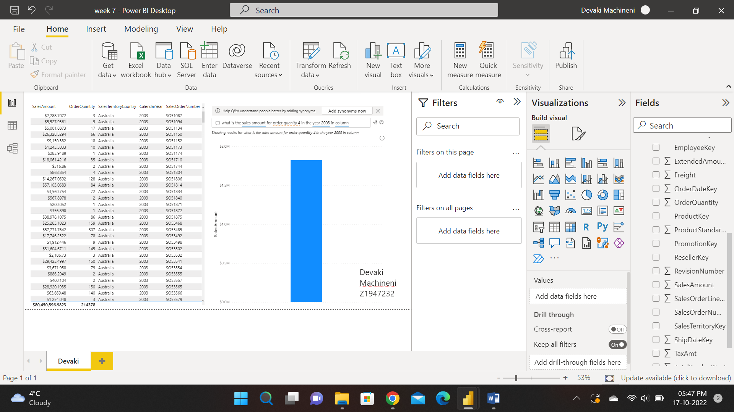

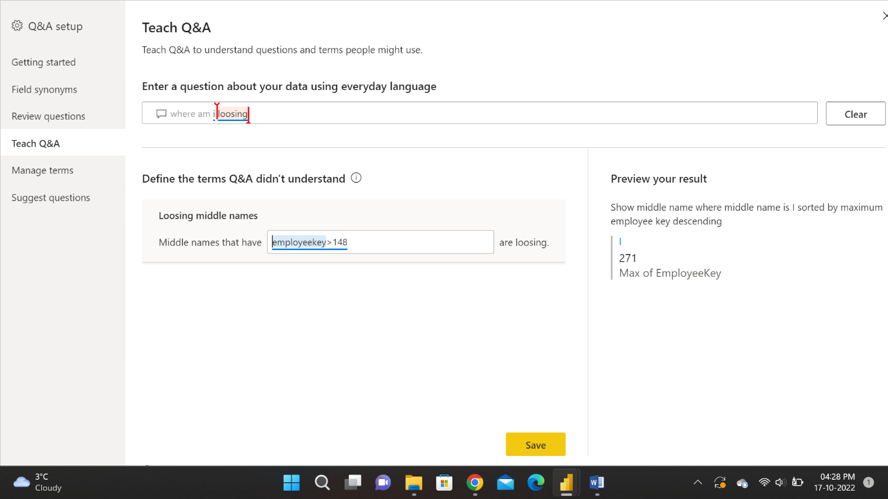

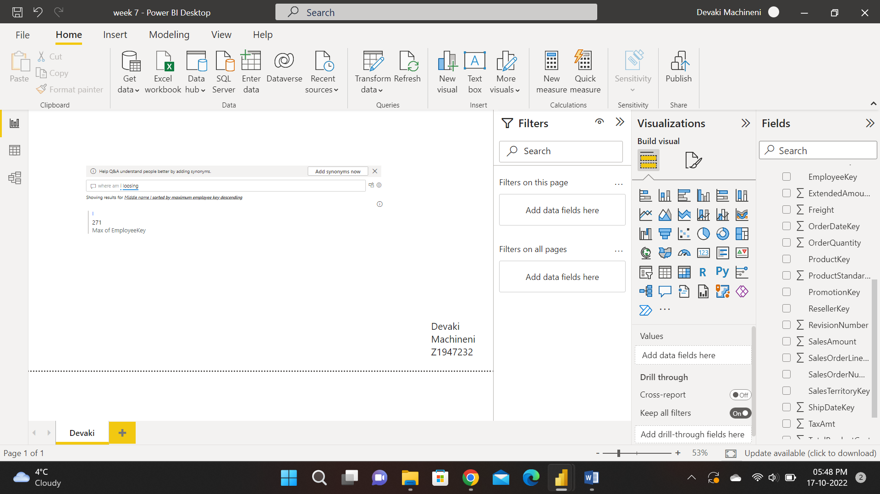

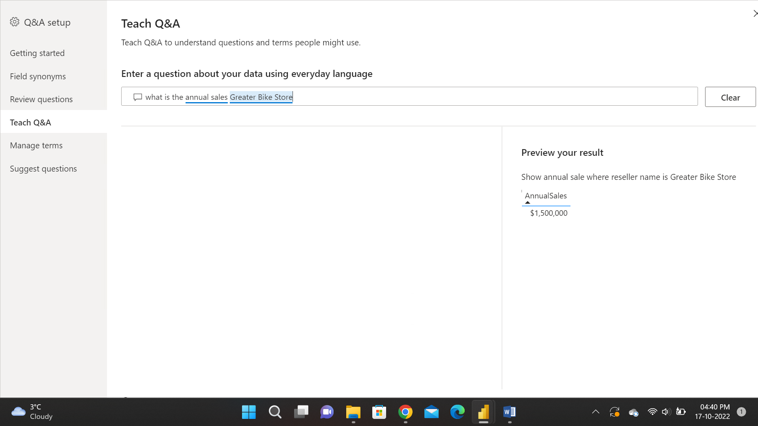

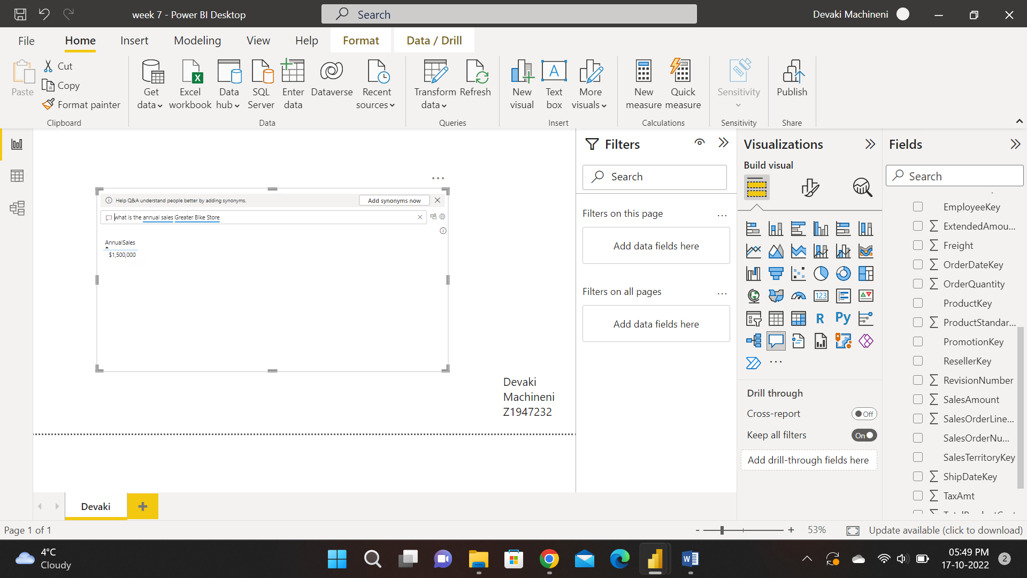

2. Examine a data file of *CustomerFeedback.xlsx*. Apply the Key Influencers technique in Power BI and write a report on what factors influence customer Rating to be High.

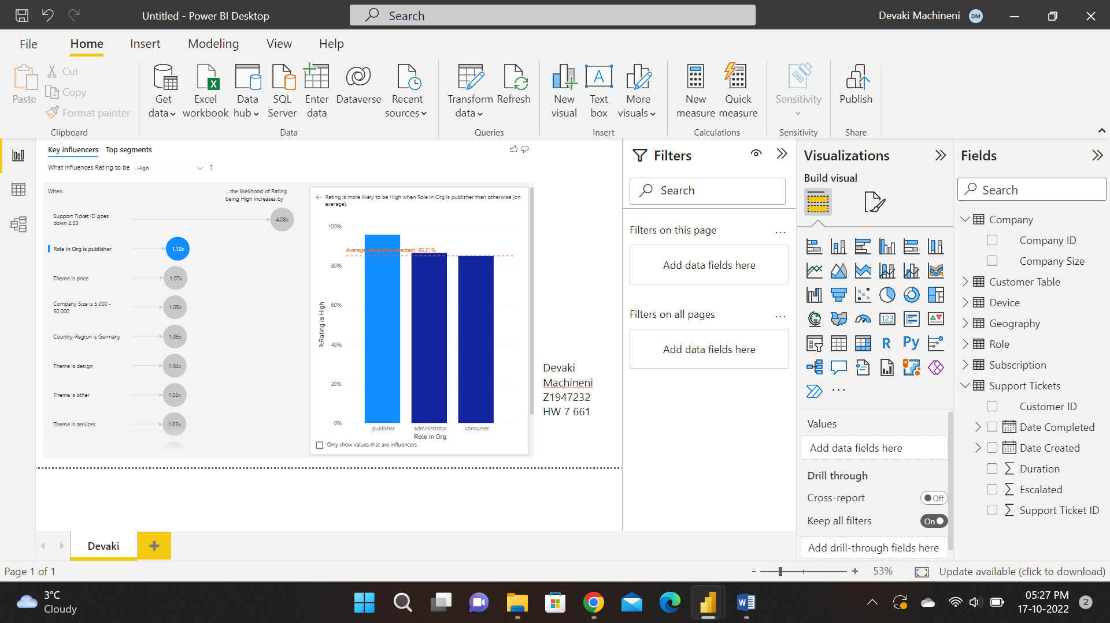

**Report:**

The above screenshot describes the role in organisation which has three influencers which are publisher, administrator and consumer. In this Publisher is 93%, administrator is 85.21%, consumer is 85% approximately. The average of role in organisation 85.21%. So, the report says that the publisher has the highest rating in influencing the customer rather than administrator and consumer.

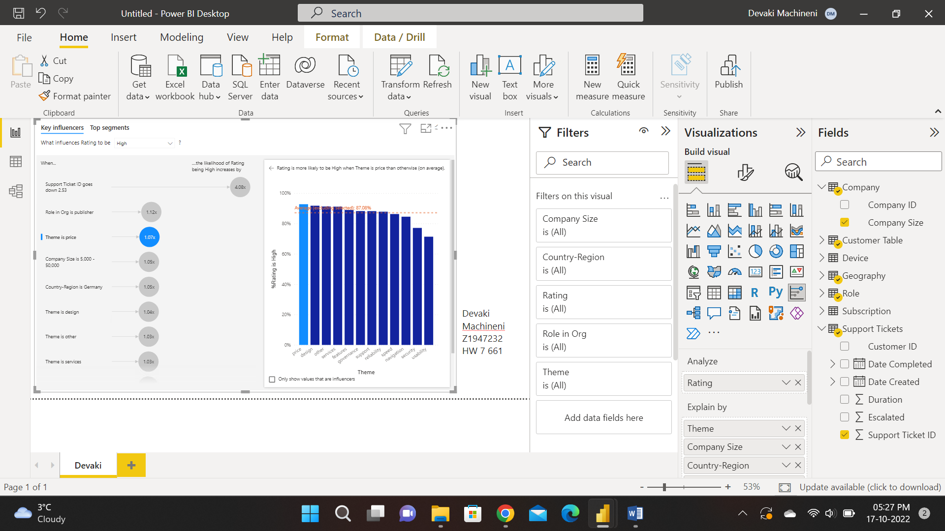

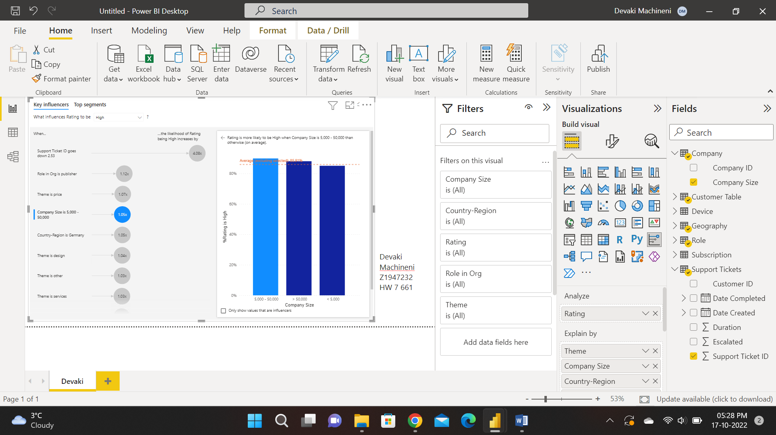

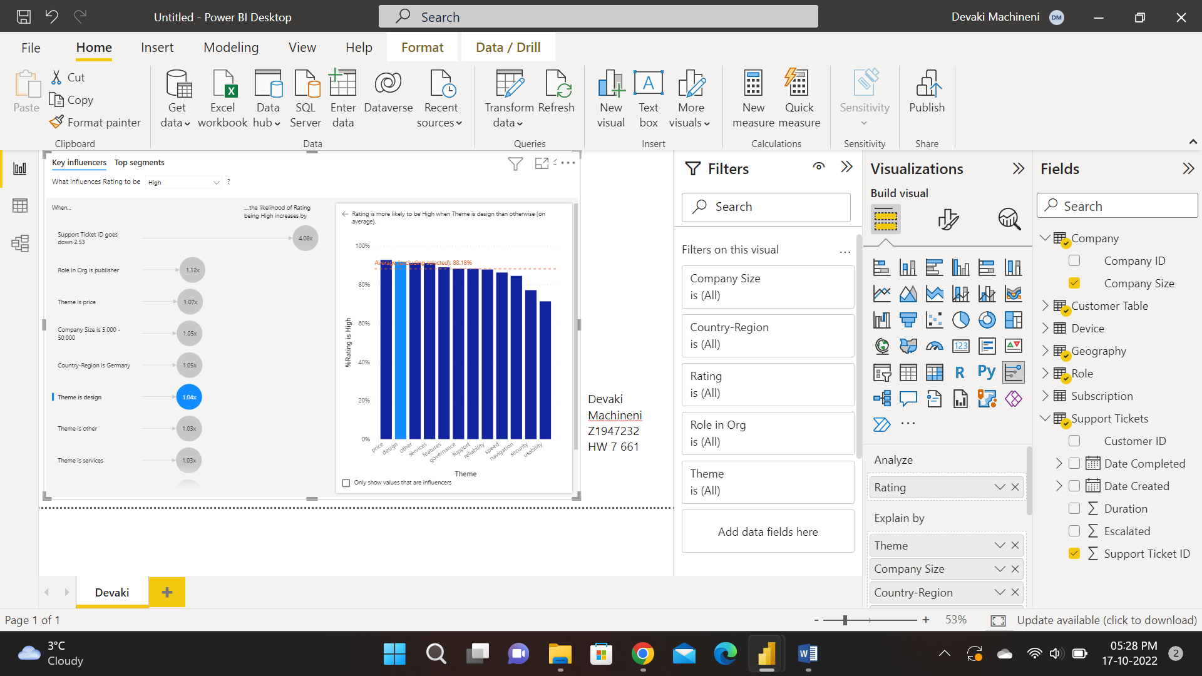

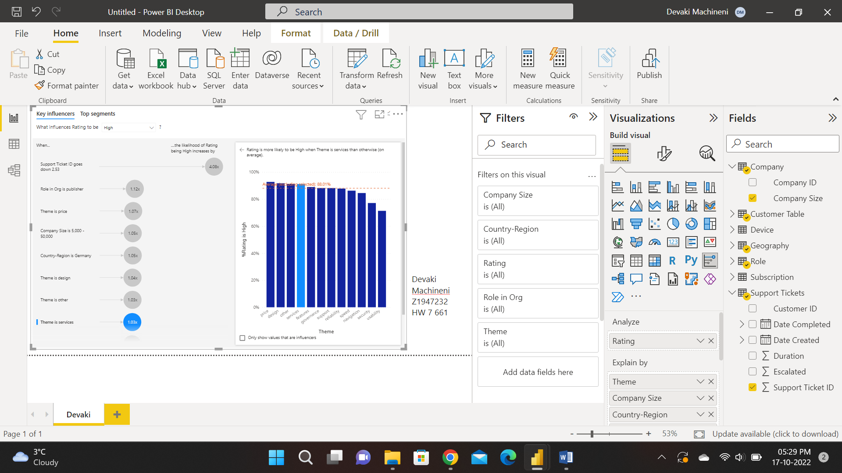

3. Examine a data file of *Service Comments Excel.xlsx*. Apply the Text Analytics technique in Power BI to extract key phrases and to score the sentiment from the comments. *Which topic received the most negative comments?*  
